**Topic description**

This topic is about “User Experience Design Learning App”, which is an Android application based on the given example from UXPA poster[1] with the title “Designing the User Experience”. The poster shows an illustrated path of how to develop more useable products via a specific process/pipeline.

It is like a big boardgame with ladders and fallbacks, which can give the user an additional boost or a negative behavior. There are of course nice other illustrations of the user centered design phases, but in this case it is very intuitive and simple, see Figure 1.

The main pipeline of the illustrated path is divided into four phases or stages:

* Analysis
* Design
* Implementation
* Deployment

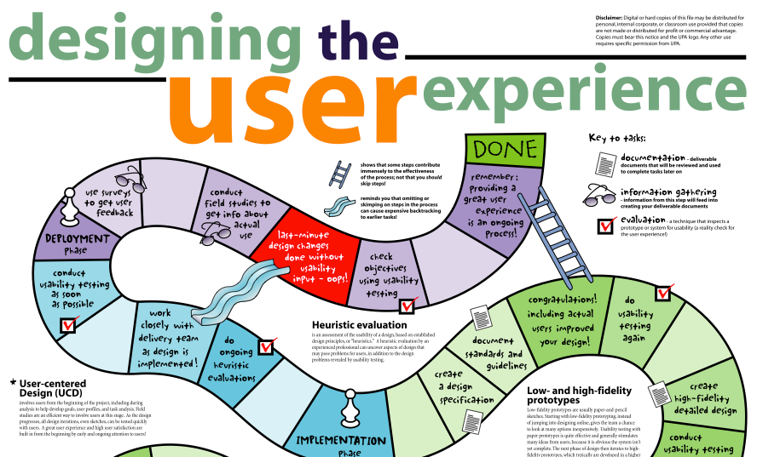

Figure 1 (http://www.mprove.de/script/00/upa/_media/upaposter_11x17.pdf, 2014)

Our main task in this course is to develop an application for mobile devices, especially Android, which can be used to get a fresh learning experience about user experience design. A custom visualization of the above described process pipeline has to be invented in an iterative design process. The user of the application should learn the details from the different phases, taken from the poster, in an easy way. The app simulates the behavior of the illustrated boardgame from the UXPA poster, to get a similar feeling.

The final application should fulfill the following additional criteria (taken from the lecture slides’):

* Basic functionality: navigation between detail + content
* Content integration (based on lecture slides)
* Help screen
* Splash screen
* Any settings/preferences that are required to be set shown on first run
* Localization (English/German) & themed
* Android 4.0 platform
* Bugfree
* Documentation

Another nice similar example is the user-centered design iceberg depicted on the same website as Figure 1 (http://www.mprove.de/script/00/upa/_media/upaposter_11x17.pdf, 2014).

**Task responsibility**

|  |  |
| --- | --- |
| Basic Implementation (Core functionality, interaction with the 3D-Scene, Android navigation structure, technical documentation) | **Florian Schweitzer** |
| Design Implementation | **Thomas Jäger** |
| Content | **Both** |
| Status report 1 | **Thomas Jäger** |
| Status report 2 | **Florian Schweitzer** |
| Status report 3 | **Both** |
| Written report | **Both** |
| Presentation | **Thomas Jäger** |
| Evaluation | **Florian Schweitzer** |

**App structure/architecture**

We had a lot ideas for designing an app like described above. But the most ideas were not feasible or even to easy or to boring .We conducted some inspiring brainstorm sessions to find the best one. But our problem was always we did not know how much effort would take our implementations or how experienced should we be in this field to handle such an application.

We made some basic rules in our first brainstorming session, which we absolutely want to meet:

* Easy navigation between phases
* The user should not get frustrated because of the usability
* The less views/activities the better
* Something with 3D visualization

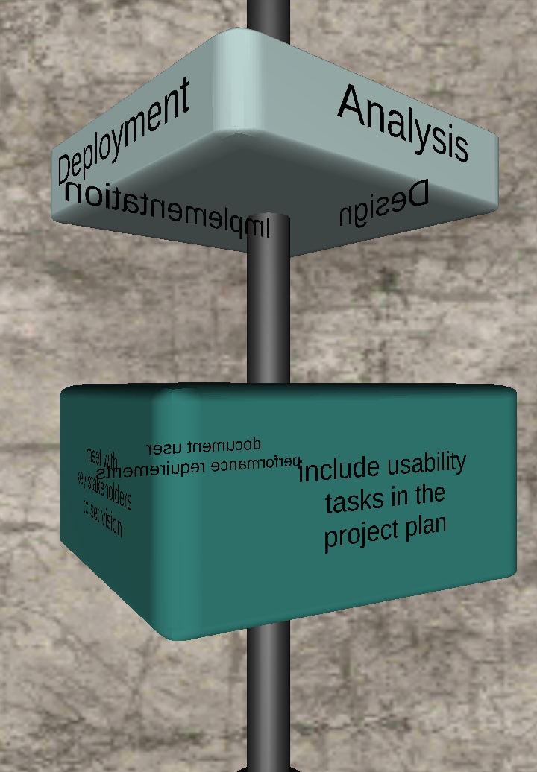**Architecture**

Our application consists of the following screens, which are held very clear and simple

**Splashscreen**

We use the Splashscreen to give the user some impressions from our app for a few seconds. It consists of the basic element from our app, the 3D Scene with the anchor. The user cannot do anything on this screen, it is only describing our app briefly and shown for a few seconds.

Figure 2

**Mainscreen**

After passing the Splashscreen, the user comes directly to the mainscreen, which consists of your main functionality. There is a big Unity3D Scene embedded in native Android UI elements. The 4 main phases are displayed on a cube, which can be rotated via swiping to another side (the cube automatically locks at the faces from the 3D-Object). Because this is the main part of our app, the navigation structure starts here. A navigation drawer can be opened via swiping from left to right or clicking at the indicator button on the upper left side. In the actionbar there are also the “Help-Button” for the help screen and the “Settings-Button” for going into the settings.

It is very simple and intuitive for the user to see what he can do now on this screen:

* Rotate the cube via swiping, to see the other faces
* There is a navigation drawer icon – lets click it?
* Watch the help screen
* Go to the settings

Probably the user doesn’t know at first how rotating the upper cube influences the cube on the bottom. But after trying, it is clear that the content of the bottom cube belongs to the rotation of the upper cube. In other words, the detail content or view of the basic phases, are displayed on additional 3D-Objects.

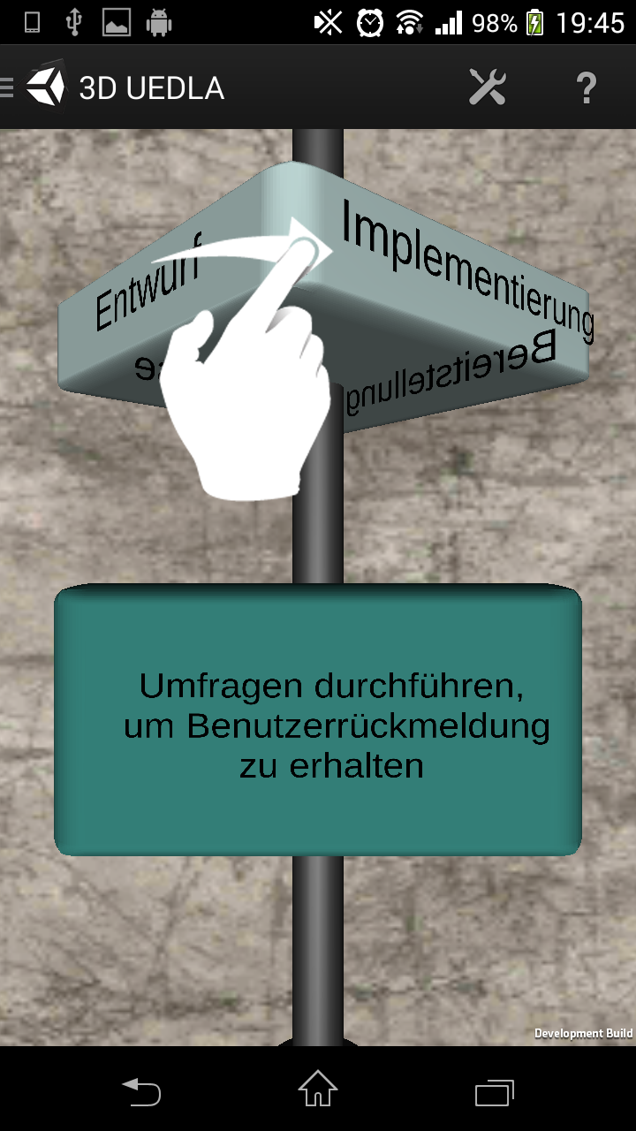

Figure 3

Figure 3 shows an example where the user swipes to the “Entwurf” phase and gets displayed the first detail content on the other cube, which is “Umfragen durchführen, um Benutzerrückmeldungen zu erhalten”

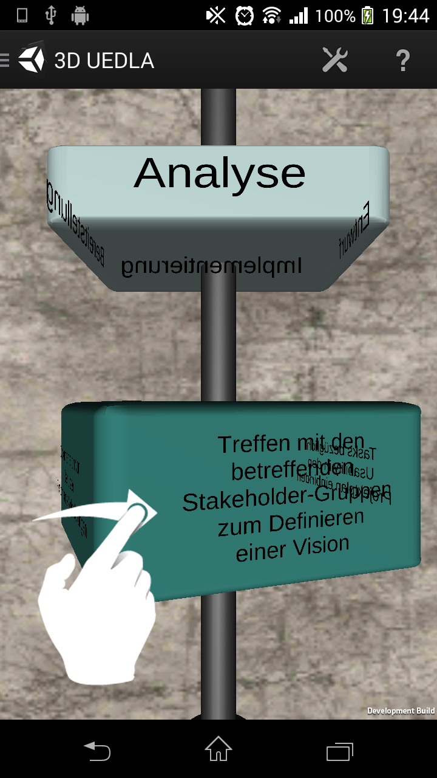

Figure 4

Figure 4 illustrates that all 3D-Objects can be handled in the same way. This is necessary because a phase could have more than one detail contents to display.

To give the user an overview about the dimension of the content a new navigation element is used to fulfill this requirement. Because we need space in our 3D-Scene we selected a navigation drawer which overlays our main screen.

The navigation drawer consists the four main categories, which can be expanded to see the detail contents. Each detail content, can be selected to view it in the 3D-Scene, this behavior is illustrated in Figure 5.

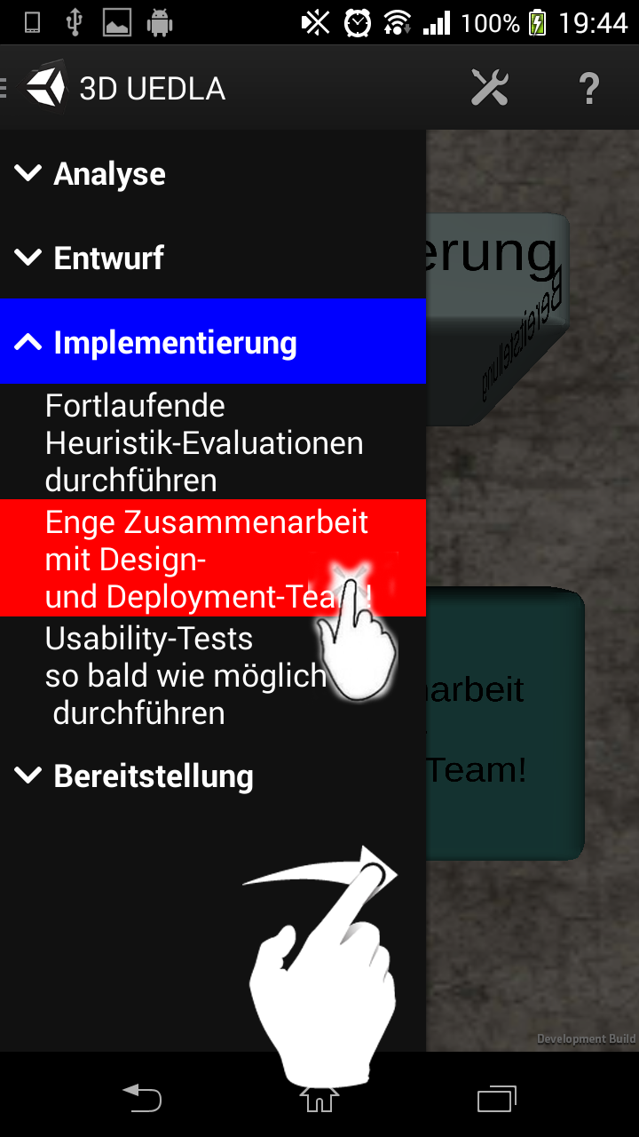

Figure 5

**Seetingsscreen**

The settingsscreen is the last one in our architecture description. The user can select his favorite theme via calling the settings menu from the action bar.

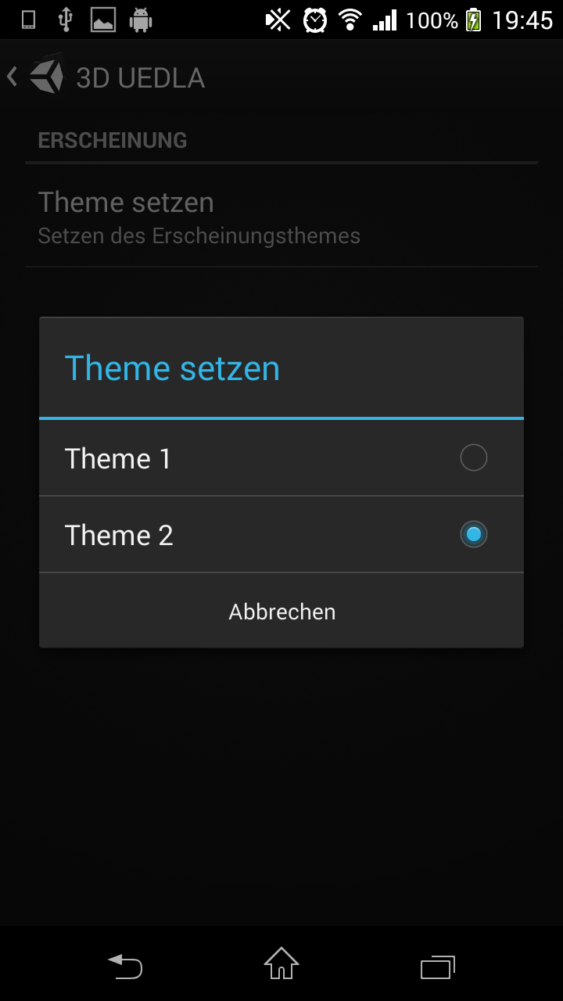

Figure 6

All this screens and the relation to each other is displayed in Figure 7

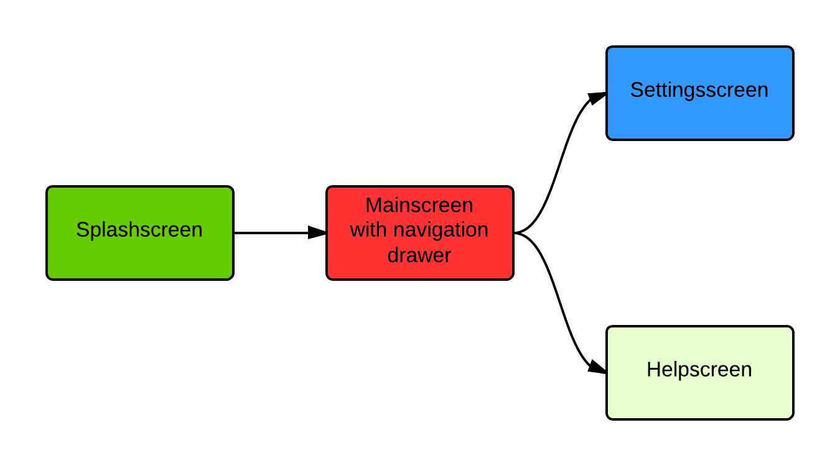

Figure 7

**Iterative design process**

As already mentioned, the user-centered design lifecycle can be roughly divided into 4 basic phases. We have decided to document the progress individually for each iteration and iterated over these phases until come to a satisfactory result. We used paper prototyping to roughly mock-up your ideas and for easier improving after the testing phases. These mock-ups were shown to other students and their feedback was incorporated in the next iteration.

**Cycle 1**

We had no clue if our approach is to difficult for the user or to complicated to implement, but we started with some little drawings from our basic navigation element. The following picture is a rough mock-up from our first ideas, which we discarded.

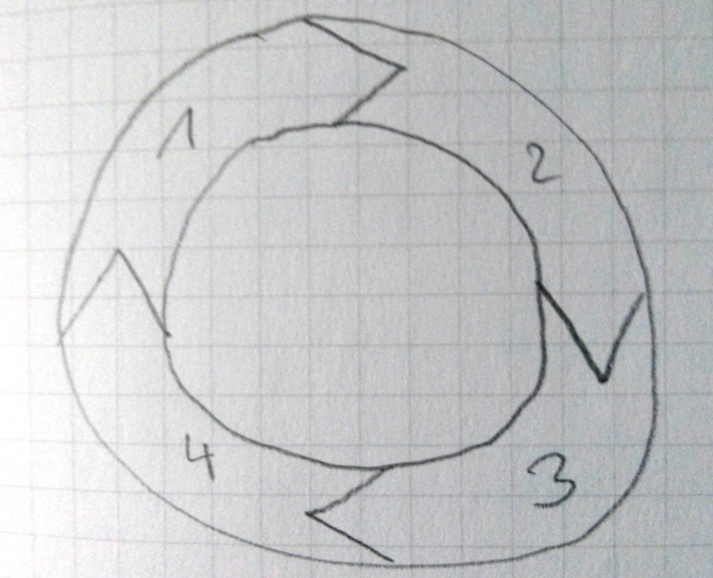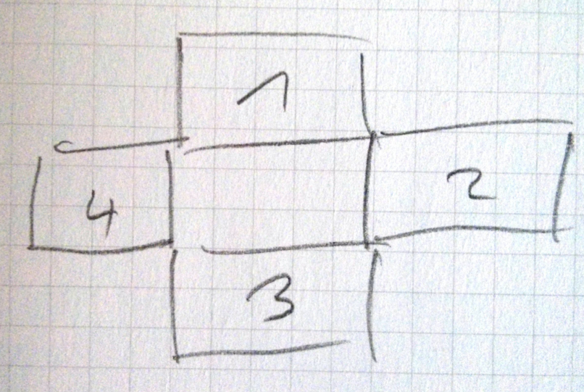

Figure 8

We decided to implement something fancier and easier, because we wanted to do something with 3D-Stuff. The following pictures are the result of our first iteration and the thoughts we had at that moment.

|  |  |
| --- | --- |
|  | * **Rotating cube** * **Indicator - button to rotate. Easy input control - cannot be misinterpreted.** |

**Cycle 2**

After our first feedback evaluation session, we came to that point that we should build up / extend our 3D-Scene because there is much more space to use on modern devices. We adapted the design to a “multiobject” approach. Instead of one big element for the main phases, we added another objects for the detail views. A navigation drawer is the right navigation element for our approach, because it needs no space when it is not expanded and when it is expanded there is a lot of space in it. And we need that for the app structure.

|  |  |
| --- | --- |
|  | * **Many 3D-Objects for different navigation levels** * **The information for this phase or its details is directly on the cube** * **Swipe gesture for rotating** |

|  |  |
| --- | --- |
|  | * **First mock-up from our navigation drawer** |

|  |  |
| --- | --- |
|  | * **Content of our navigation drawer** * **Difference between master and detail view is shown through indentations** * **All elements are selectable in the navigation drawer** |

|  |  |
| --- | --- |
|  | * **First design of our splash-screen** * **Should be simple an clear** * **Looks like the main screen** * **Is shown for a few seconds** * **Is not clickable** * **Should the user inform about what he can do** |

**Cycle 3**

We got nice feedback after the last cycle. We changed minor things and made a fancy paper prototype

|  |  |
| --- | --- |
|  | * **At a real device (or in this case a printed out device) we saw that we have enough space for content** |

|  |  |
| --- | --- |
|  | * **Also in the navigation drawer is enough space for content** |

|  |  |
| --- | --- |
|  | * **Another face of the cube** |

|  |  |
| --- | --- |
|  | * **Low level detail view** * **Big space for content** * **Button to close the detail view** |

**Evaluation feedback**

**Development phase**

* We captured our feedback during the development phase with 8 colleagues. The 8 students were from 4 different project groups. Based on the paper prototype it was very hard to retrieve good feedback, because the 3D-Vision is very difficult to replicate on paper. The difficult part was that the test user could not imagine the 3D rotation actions and flows. We used “Think alouds“ (direct observation) method to retrieve the feedback to get as many as possible situations und unusual situations.

The following lists shows all critical comments regarding our paper prototype. This list is split in 2 groups, one for the comments or features we realized and the other one, which we have not implemented in the further design process.

|  |  |
| --- | --- |
| Changed behavior | Not implemented |
| * Navigation drawer for menu structure * No logo in splash screen * Bigger 3D-Objects * Icons in the navigation drawer * No buttons in the 3D-Scene * Swipe gestures * Colored objects | * No 3D-Scene * Buttons instead of swipe gestures * Sound |

We recognized additionally, that the anchor like in Figure 9 was a good decision, because we had the big problem, that the user don’t know how to interact with the app at first. After a long time of trying the real navigation flow was recognized.

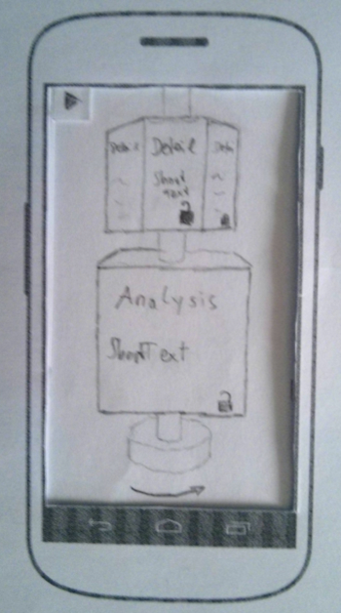

Figure 9

**App evaluation**

Because the implementation of the app took much longer as expected (cause of the 3D stuff) we unfortunately have exceeded our last deadline. This had to follow that we could not get eight test-user for testing our finished application.

Some feedback we collected:

|  |  |
| --- | --- |
| Changed behavior | Not implemented |
| * Graphics could be fancier * The rotating of the cube lags a little bit * Splash-screen is displayed to long | * Graphics could much more fancier * Rotating could be smoother |

**Design decisions**

We took that design, because it is very simple and intuitive. During our test phases we saw that the test user always know what to do. The navigation drawer helps us a lot to kick out temporary unnecessary things.

**Conclusion**

We have noticed in the course of the implementation phase that we had better pay attention to the complexity of 3D applications during brainstorming. Who thought that would be a nice idea to put some interesting 3D-Stuff inside, but it made the thing much more complicated. We would have saved a lot of time if we had taken a more simple approach. Unity is useless in team development, because it can not be treated via GIT because of binary files.

1. http://www.usabilityprofessionals.org/upa_publications/ux_poster.html